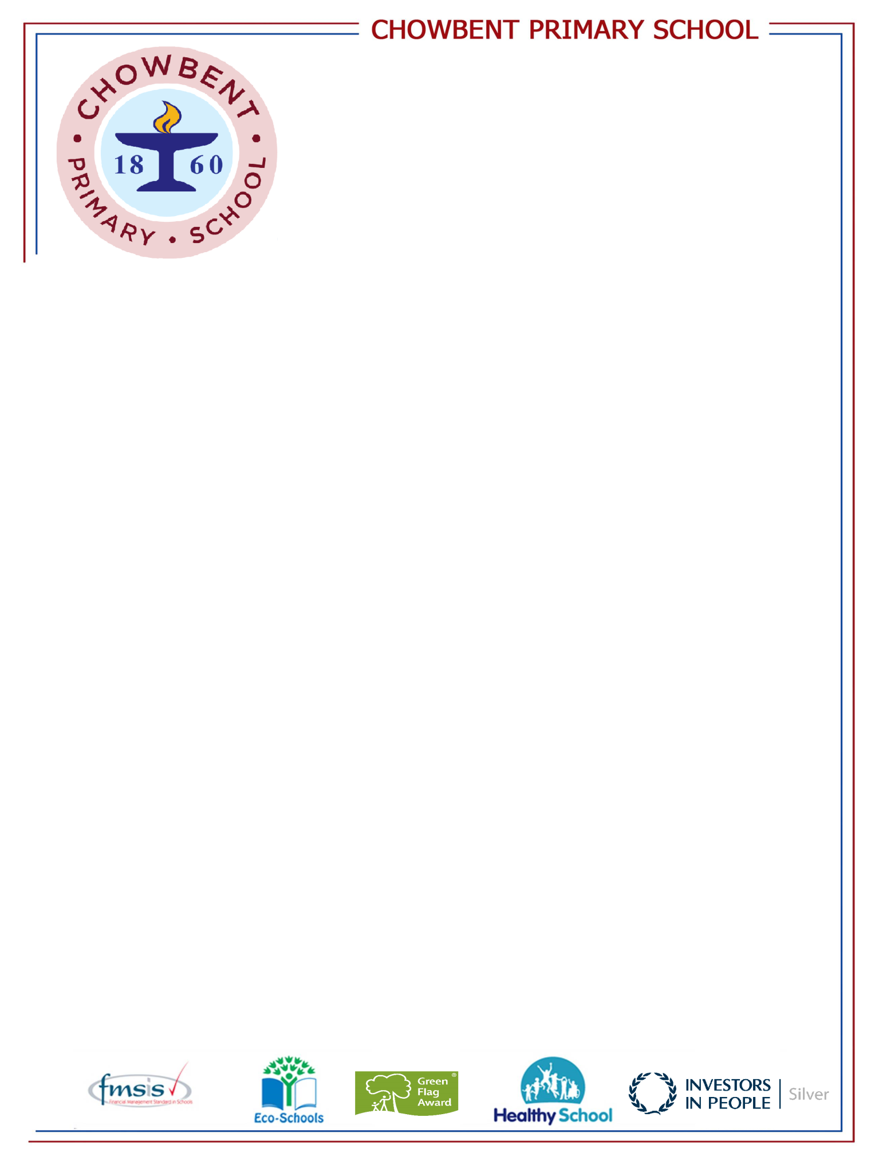
Laburnum Street
Atherton
Manchester
M46 9FP
Telephone: (01942) 883410
Fax: (01942) 897773
E-mail: enquiries@admin.chowbent.wigan.sch.uk
Web: www.chowbent.wigan.sch.uk

As a healthy eating school, we advise that all children, who bring a packed lunch to follow these guidelines:

Suggested items suitable for a lunch box are:
Sandwiches
Pieces of raw vegetables or pot of salad
Pasta with dressing
Fruit
Yogurt
Cereal bars
Mini cheeses e.g. Dairylea/Babybel
Small biscuit or cake bar

The following items are not suitable for lunch boxes:
Chocolate and chocolate spread (Chocolate covered items such as biscuits are to be limited to one small item)
Sweets
Fizzy drinks or drinks high in added sugar.

It is important that children receive enough nutrition in their lunch, to get them through a busy afternoon and that sugary items are limited.
Please keep this in mind when putting a packed lunch together for your child.
Mr J.Randle
Headteacher

