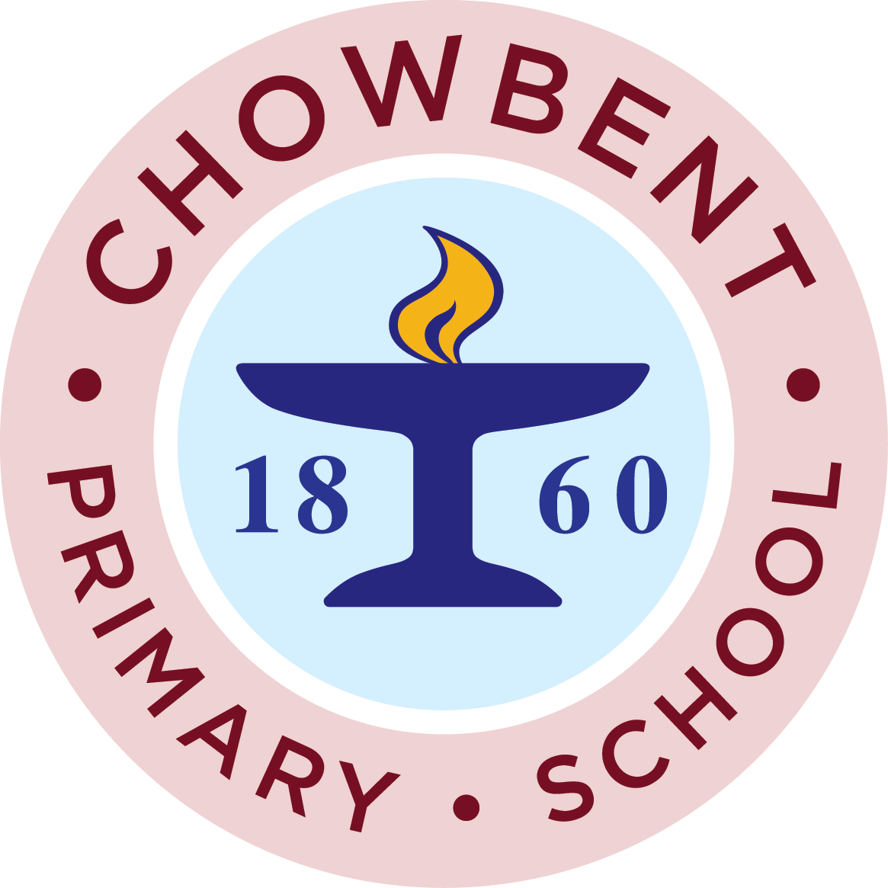

PTFA News

We have had a quiet Easter term after the hustle and bustle of the Christmas term. It was suggested to us that we had too many events for parents to fully support. So this term we have limited ourselves to the Young Voices concert and the upcoming Bingo. The Easter bingo is on
Wednesday 28th March at 6-30pm. We do hope that you will come along and support this.
We have 2 meetings coming up and we would be interested to hear what you think about what events we hold and how many. They are on Tuesday 13th March at 7-30pm in The Royal Inn and then for tea and toast in school on Friday 16th March. Please feel free to come to either or both of these events. We would really love to see you.
Sue ( PTFA chair)

