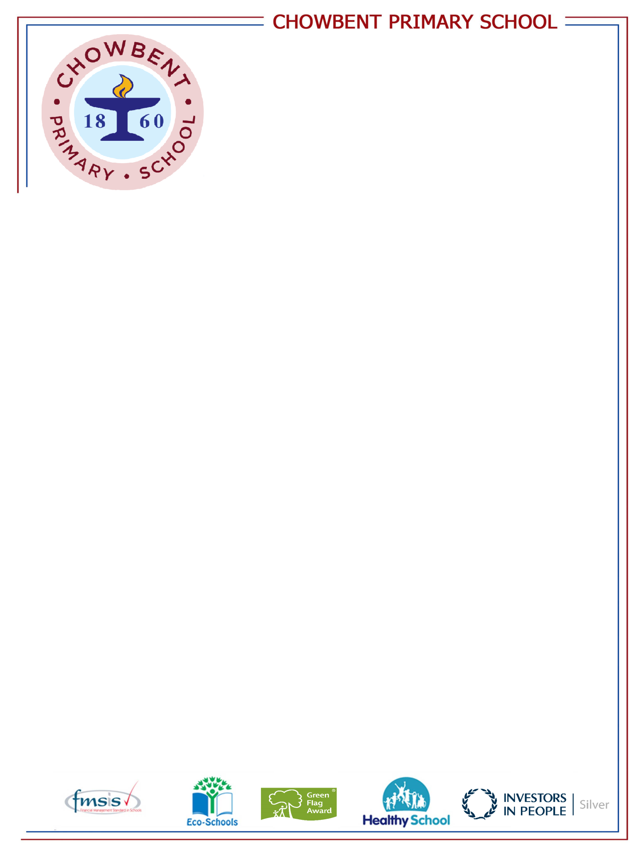
Laburnum Street
Atherton
Manchester
M46 9FP
Telephone: (01942) 883410
Fax: (01942) 897773
E-mail: enquiries@admin.chowbent.wigan.sch.uk
Web: www.chowbent.wigan.sch.uk

Book Fair

We will be holding our annual Book Fair after school on Monday 12th March – Friday 16th March. We have a £1 book voucher for each child to be used at the book Fair. Any additional money raised from the Book Fair sales will be used to support the development of the school's lending library.

