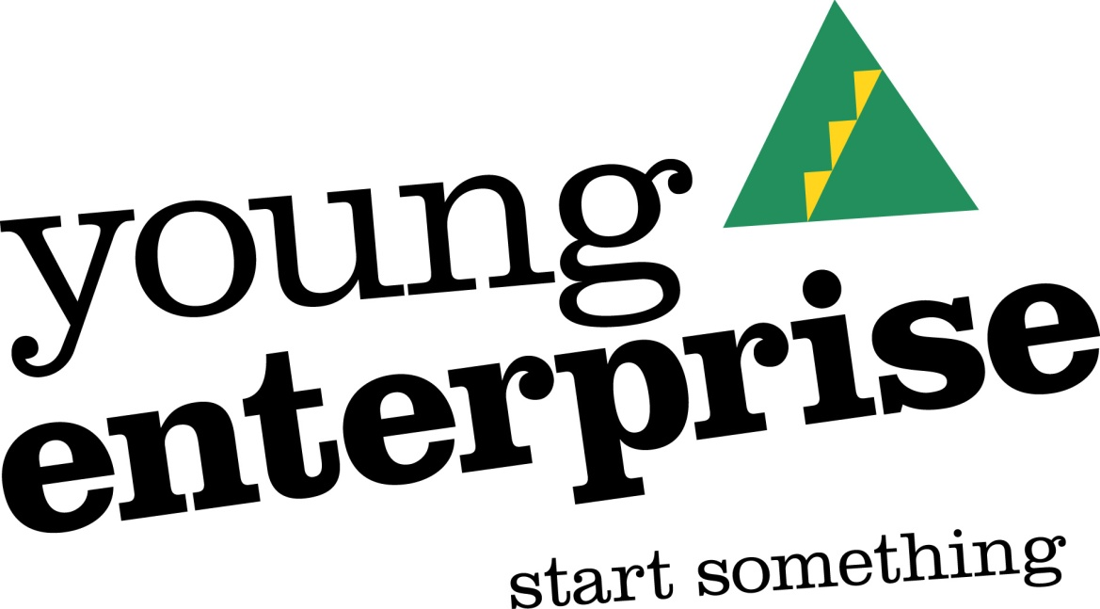
Dear Parents and Carers,
As you know Young Enterprise are making homemade scented candles and we would like to know if you would like to buy a small, medium or large candle.
The prices are:
Large - £5:00
Medium - £4:00
Small - £3:00
Please fill in the form and return it with the money by Monday 5th March.
Thank you,
The Young Enterprise Team x
………………………………………………………………………………………………………………………………………………………………………………………
Please write down the number that you would like in the spaces provided.

I would like …………… large, …………. medium and/or …………… small candles for the price of £……………………….

Child’s Name………………………………………………………………………………………………………………………………………………………
Child’s Class……………………………………

