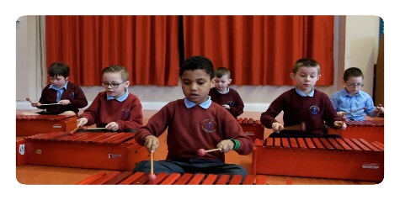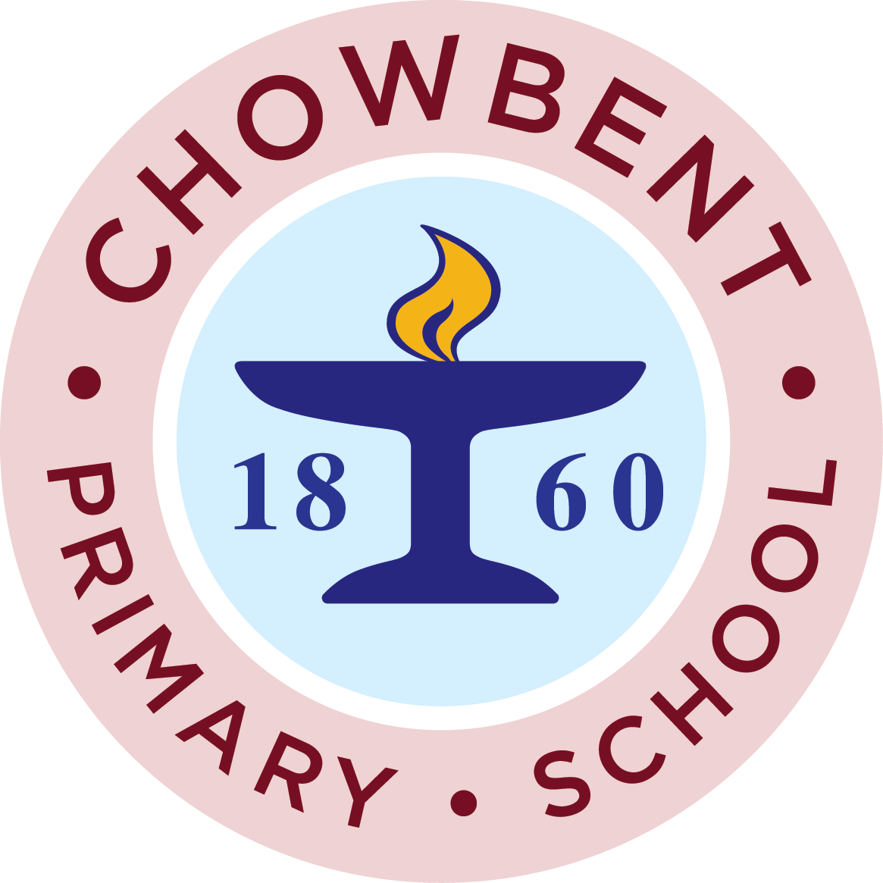

Chowbent Primary
School

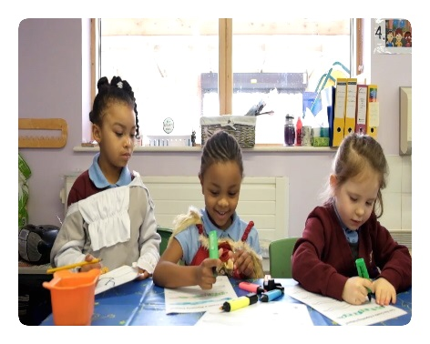
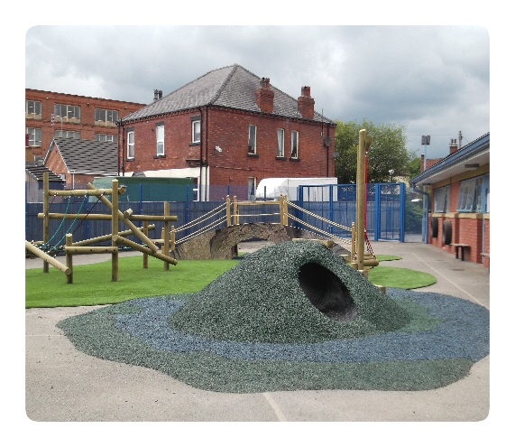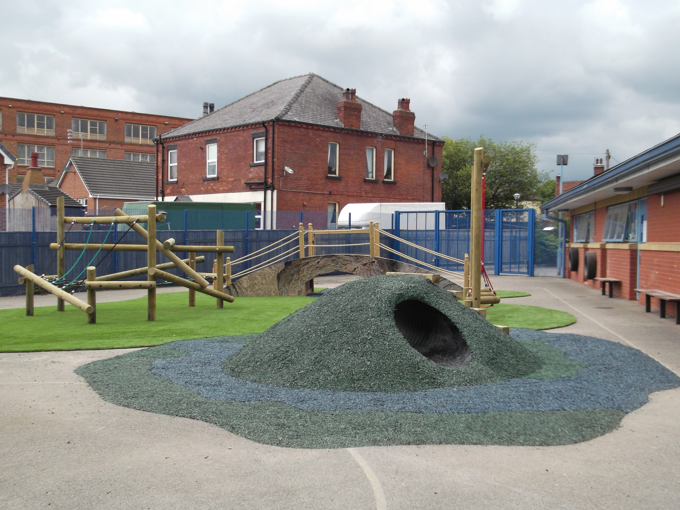

Dear Parents/Carers,

We would like to invite you to an Open Day at Chowbent Primary School on Tuesday 13th November, at the following times 10.00-11.00am and 1.30-2.30pm, where you will see our school in full operation. If you are unable to attend our Open Day, you can join us for our evening session 6.15–7.15pm.

Our current pupils will give all parents and their child a tour of our school. During the tour you will be given the opportunity to meet our reception class staff, who will be able to answer any questions you may have.

We are looking forward to meeting you and your child

Headteacher: Mr J Randle
Chowbent Primary School,
Laburnum Street
Atherton
M46 9FP

Tel: 01942 883410
Web: www.chowbent.wigan.sch.uk
Email: enquiries@admin.chowbent.wigan.sch.uk

Open Day

