Non uniform
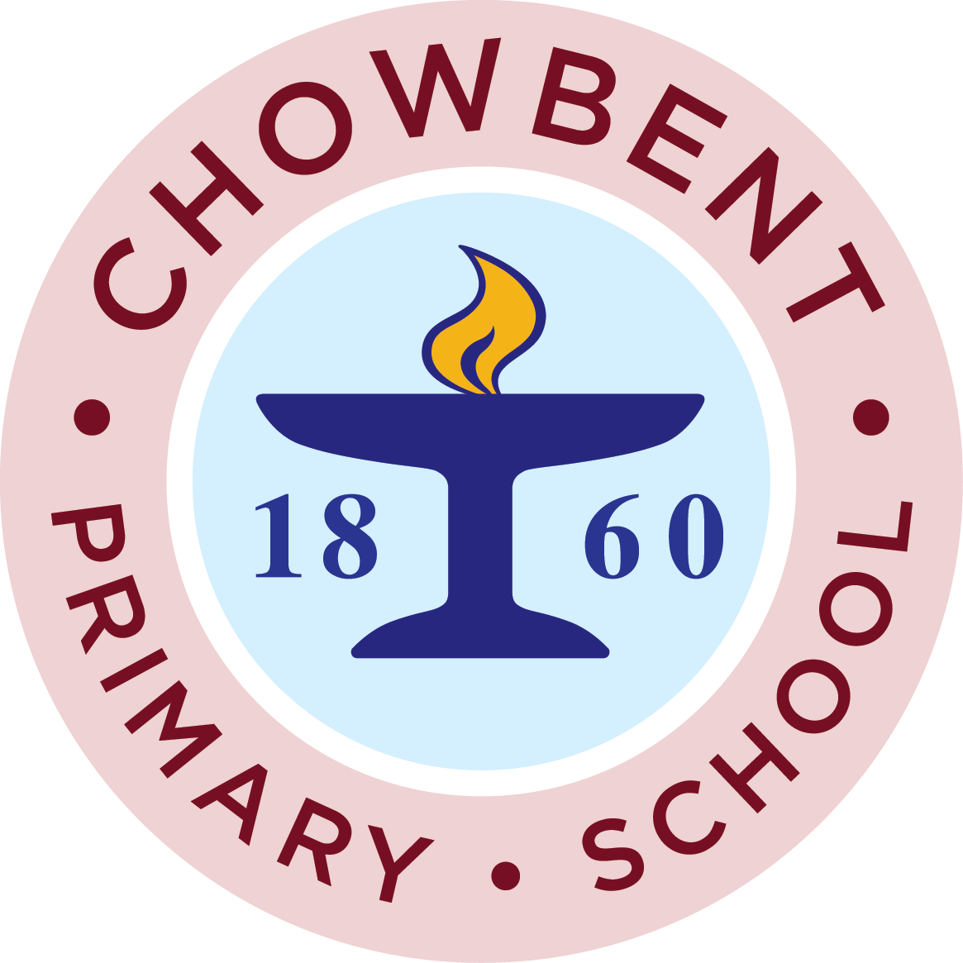
We are having a non uniform day on Thursday 18th October. We are asking for bottle or unused gift donations. These will be used in our Christmas tombola on November 15th. If you have a spare gift bag to send we would be very grateful. If you would prefer you can send £1 and we will use your donations to purchase items to be used at this event.

The next meetings to which everyone is welcome are on:
Thursday 18th October at 7-30 pm in The royal
Tea and toast morning on Friday 2nd November
Have a good half term !
If you are starting to clear out at home ready for Christmas we will be asking for donations of teddy bears, books and items of bric a brac after the holiday.

