25th May 2018

Dear Parent/Guardian,

As you may already be aware, the 25th May 2018 marks the enforcement of the General Data Protection Regulation (GDPR). The GDPR will replace the Data Protection Act 1998 and is designed to strengthen the safety and security of all data held within an organisation, and make sure processing and storage procedures are consistent.

I am writing to you today to inform you of the work that the we are doing to ensure that we meet this new regulation.

Primarily, it is important that you understand your rights under the GDPR; you have the right to:

- Be informed about how we use your personal data
- Request access to the personal data that the school holds
- Request that your personal data is amended if it is inaccurate or incomplete
- Request that your personal data is erased where there is no compelling reason for its continued processing
- Request that the processing of your data is restricted
- Object to your personal data being processed

The GDPR will result in some significant changes for the school, which I would now like to take a moment to explain. The school needs to prove its compliance with the GDPR, by having effective policies in place. There have also been some changes to the rights that individuals have – such as the right to have your information erased.

Privacy notices must also include new information, such as an individual’s right to complain to the Information Commissioner’s Officer (ICO). The GDPR takes into account the information of children too – parental consent, is required, for children up to the age of 13, at which point, the child may be able to consent for itself. Privacy notices must be given to children and have to be written using age-appropriate language.

A data breach notification duty is applied to all schools, and those that are likely to cause damage, e.g. identity theft, have to be reported to the ICO within 72 hours – failure to do so can result in a fine. A data protection impact assessment will be completed, which will likely be carried out when using new technologies and the processing is likely to result in a high risk to the rights and freedoms of individuals.

One of the biggest changes has been in terms of consent; consent must be a ‘positive indication,’ which means that it has to be opted into, clear and unambiguous. Any consent given under the Data Protection Act 1998 will be reviewed and reobtained if necessary. This means the school may have to ask you to consent to things again.

Finally, schools are required to appoint a data protection officer (DPO). The school will inform you as soon as a suitable candidate is appointed.

The GDPR will require changes to be made to some school policies and procedures. While some policies will need small updates, others will require re-writes. For example, the school’s Photography and Videos Policy will need quite a few changes and, for this reason, I would like to ask you to complete the enclosed consent permission slip and return it to the school office, once you have read and understood the school’s privacy notice, which is also enclosed. Before you give consent to anything, it is vital that you have read and understand the privacy notice, as the school wants to ensure that you understand what we are doing with your data and that you know we are acting legally.

When policies have been checked and ratified, they will be published on the school’s website, which can be accessed here: www.chowent.wigan.sch.uk

If you have any questions about GDPR, you can contact the ICO on 0303 123 1113, or you can visit their Guide to the General Data Protection Regulation webpage. You are also welcome to direct any questions you have to the DPO when appointed.

Please find attached consent forms for various activities in school. Please complete, sign and return to school asap.

Yours faithfully,

Mr J Randle
Headteacher

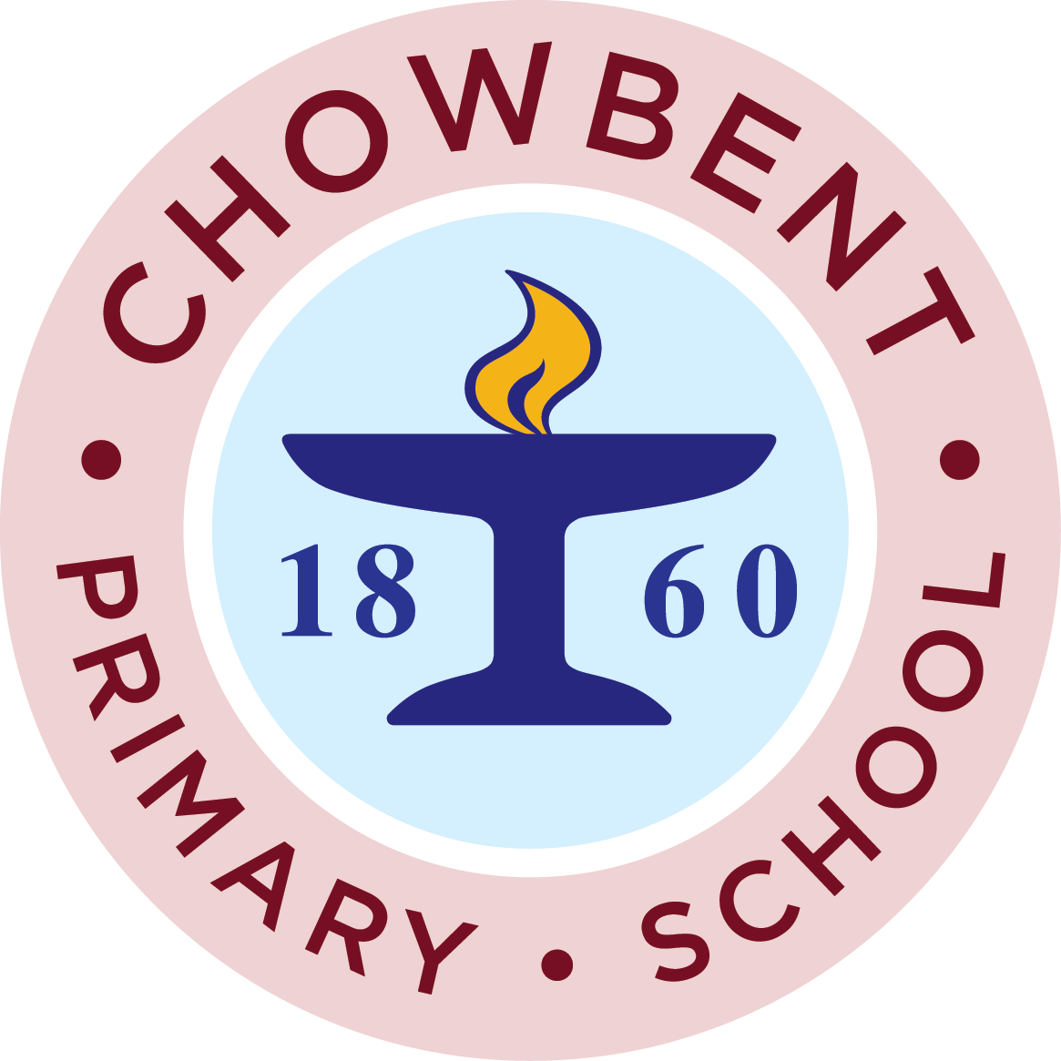
PRIVACY NOTICE – Parents/Guardians
(How we use pupil information)

Under data protection law, individuals have a right to be informed about how the school uses any personal data that we hold about them. We comply with this right by providing ‘privacy notices’ to individuals where we are processing their personal data.

This privacy notice explains how we collect, store and use personal data about pupils.

We, the school, are the ‘data controller’ for the purpose of data protection law.

Our data protection officer (DPO) is – TBC

The personal data we hold

Personal data that we may collect, use, store and share (when appropriate) about pupils includes, but is not restricted to:

- Contact details, contact preferences, date of birth, identification documents.
- Results of internal assessments and externally set tests.
- Pupil and curricular records.
- Characteristics, such as ethnic background, nationality, language, country of birth, eligibility for free school meals, or special educational needs.
- Exclusion information.
- Details of any medical conditions, including physical, mental health and special educational needs and disabilities.
- Attendance information.
- Safeguarding information
- Details of any support received, including care packages, plans and support providers.
- Photographs.
- CCTV images captured at school.

We may also hold data about pupils that we have received from other organisations, including other schools, local authorities and the Department for Education.

Why we use this data

We use this data to:

- Support pupil learning.
- Monitor and report on pupil progress.
- Provide appropriate pastoral care.
- Protect pupil welfare.
- Assess the quality of our services.
- Carry out research.
- Comply with the law regarding data sharing.

Our legal basis for using data

We only collect and use pupils’ personal data when the law allows us to. Most commonly, we process it where:

- We need to comply with a legal obligation.
- We need it to perform an official task in the public interest.

Less commonly, we may also process pupils’ personal data in situations where:

- We have obtained consent to use it in a certain way.
- We need to protect the individual’s vital interests (or someone else’s interest).

Where we have obtained consent to use pupils’ personal data, this consent can be withdrawn at any time. We will make this clear when we ask for consent, and explain how consent can be withdrawn.

Some of the reasons listed above for collecting and using pupils’ personal data overlap, and there may be several grounds that justify our use of this data.

Collecting this information

Whilst the majority of information we collect about pupils is mandatory, there is some information that can be provided voluntarily.

In order to comply with the General Data Protection Regulation, we will inform you whether you are required to provide certain pupil information to us or if you have a choice in this.

How we store this data

We keep personal information about pupils while they are attending our school. We may also keep it beyond their attendance at our school if this is necessary in order to comply with our legal obligations.

Data sharing

We do not share information about pupils with any third party without consent unless the law and our policies allow us to do so.

Where it is legally required or necessary (and it complies with data protection law) we may share personal information about pupils with:

- Our local authority – to meet our legal obligations to share certain information with it, such as safeguarding concerns and exclusions.
- The Department for Education – to meet our legal obligation as the data underpins school funding and educational attainment policy and monitoring. We are required to share information about our pupils with the (DfE) under regulation 5 of The Education (Information About Individual Pupils) (England) Regulations 2013.
- The pupil’s family and representatives.
- Educators and examining bodies – to meet our legal obligations.
- Ofsted – to meet our legal obligations.
- Suppliers and service providers – to enable them to provide the service we have contracted them for.
- Central and local government.
- Survey and research organisations (with consent).
- Health authorities (with consent).
- Health and social welfare organisations (with consent).
- Professional education advisers and consultants.
- Police forces, courts, tribunals.
- Professional bodies.
- Our lunch ordering system.
- Our payment system.
- Evolve – trip planning software.
- Lancashire Pupil Questionnaire (with consent)
- CPOMS – our safeguarding tool.
- SIMS – to enable the school to record all pupil data and assessment data legally required for census.
- Inventry – our signing in and signing out system.
- Our school counsellor (with consent).
- Educational Psychology Service (with consent).
- TESS team (with consent).
- Music services
- Curriculum related applications (with consent) - Purple Mash, SATs Companion, phonics play, target trackers.
- EYFS – 2 Build a profile (with consent)
- Social Media (with consent) – website
- Marketing literature (with consent)

National Pupil Database

The NPD is owned and managed by the Department for Education and contains information about pupils in schools in England. It provides invaluable evidence on educational performance to inform independent research, as well as studies commissioned by the Department. It is held in electronic format for statistical purposes. This information is securely collected from a range of sources including schools, local authorities and awarding bodies.

We are required by law to provide information about our pupils to the DfE as part of statutory data collection such as the school census and early years’ census. Some of this information is then stored in the NPD. The law that allows this is the Education (Information About Individual Pupils) (England) Regulations 2013.

To find out more about the NPD, go to:

https://www.gov.uk/government/publications/national-pupil-databse-user-guide-and-supporting-information

The department may share information about our pupils from the NPD with third parties who promote the education or well-being of children in England by:

- Conducting research or analysis
- Producing statistics
- Providing information, advice or guidance.

The Department has robust processes in place to ensure the confidentiality of our data is maintained and there are stringent controls in place regarding access and use of the data. Decisions on whether DfE releases data to third parties are subject to a strict approval process and based on a detailed assessment of:

- Who is requesting the data?
- The purpose for which it is required.
- The level and sensitivity of data requested: and
- The arrangements in place to store and handle the data.

To be granted access to pupil information, organisations must comply with strict terms and conditions covering the confidentiality and handling of data, security arrangements and retention and use of the data.

For more information about the department’s data sharing process, please visit:

https://www.gov.uk/data-protection-how-we-collect-and-share-research-data

For information about which organisations the department has provided pupil information, (and for which project), please visit the following website:

https://www.gov.uk/government/publications/national-pupil-database-requests-received

To contact DfE: https://www.gov.uk/contact-dft

Transferring data internationally

Where we transfer personal data to a country or territory outside the European Economic Area, we will do so in accordance with data protection law.

Parents and Pupils’ rights regarding personal data

Individuals have a right to make a ‘subject access request’ to gain access to personal information that the school holds about them.

Parents/Guardians can make a request with respect to their child’s data where the child is not considered mature enough to understand their rights over their own data (usually under the age of 13), or where the child has provided consent.

Parents also have the right to make a subject access request with respect to any personal data the school holds about them.

If you make a subject access request, and if we do hold information about you or your child, we will:

- Give you a description of it.
- Tell you why we are holding and processing it, and how long we will keep it for.
- Explain where we got it from, if not from you or your child.
- Tell you who it has been, or will be, shared with.
- Let you know whether any automated decision-making is being applied to the data, and any consequences of this.
- Give you a copy of the information in an intelligible form.

Individuals also have the right for their personal information to be transmitted electronically to another organisation in certain circumstances.

If you would like to make a request please contact our School Business Manager.

Parents/Guardians also have a legal right to access to their child’s educational record. To request access, please contact the School Business Manager.

Other rights

Under data protection law, individuals have certain rights regarding how their personal data is used and kept safe, including the right to:

- Object to the use of personal data if it would cause, or is causing damage or distress.
- Prevent it being used to send direct marketing.
- Object to decisions being taken by automated means (by a computer or machine, rather than by a person).
- In certain circumstances, have inaccurate personal data corrected, deleted or destroyed, or restrict processing.
- Claim compensation for damages caused by a breach of the data protection regulations.

To exercise any of these rights, please contact our data protection officer.

Complaints

We take any complaint about our collection and use of personal information very seriously. If you think that, our collection or use of personal information is unfair, misleading or inappropriate, or have any other concern about our data processing, please raise this with us in the first instance.

To make a complaint, please contact our data protection officer.

Alternatively, you can make a complaint to the information Commissioner’s Office:

- Report a concern online at https://ico.org.uk/concerns/
- Call 0303 123 1113
- Or write to: Information Commissioner’s Office, Wycliffe House, Water Lane, Wilmslow, Cheshire, SK9 SAF

Contact us

If you have any questions, concerns or would like more information about anything mentioned in this privacy notice, please contact our School Business Manager.

- Mrs Lorraine Pembroke – enquiries@admin.chowbent.wigan.sch.uk

Consent Form

Name of Child: ______________________________________ Class: __________

Please tick the appropriate box to give consent for the following:

Trips/Visits Consent

I give consent for my child to go on local walks and trips in the Atherton area. Though we will endeavour to inform you of all visits and trips, at times these visits are organised at the last minute to take advantage of good weather e.g. going to the chapel to practise for the Harvest, a visit to the park or the unexpected organisation of sports events. At these times, it is beneficial to have a general consent form that allows us to provide opportunities for the children without worrying if we have consent or having to leave a child behind because consent forms have not been returned in time. Consent for trips outside of school time, will always be sought for separately.

Transport Consent

I give consent for my child to be transported in a staff vehicle (all staff should have insurance and driving license check).

I give consent for my child to be transported by School Shuttle or in a mini bus provided by local high schools.

Media

I give my consent for my child to:

Watch U rated films and internet clips at the discretion of the teacher.

Photography Consent

I give consent for my child to have their photography/video image taken by school and used for the purpose of:

Teaching and learning within school to aid the classroom including displays within school.

To be used on the school website/newsletter/twitter/Facebook/school app (only Christian names to be used).

To represent the school or their own achievements in the newspaper when appropriate.

To be used in the school prospectus and other school publications that are used for marketing purposes.

To remain on school publications and website after they have left school.

I give consent for the school to share my child’s data with a school- appointed external photography company for official school images. This includes the following information:

- Name

- Class

General

I give consent for my child to:

Have sun cream applied (Reception class only)

Consent for Emergency Medical Treatment

I confirm that I am willing for the school representative, to sign on my behalf, any forms of consent required by the hospital authorities in the event that my son/daughter requires emergency medical treatment, at school/residentials/school trips outside of school hours, provided the delay required to obtain my own signature might be considered by the doctor/surgeon to endanger my son’s/daughter’s health or safety.

Use of emails and mobile numbers

I give consent that my mobile number can be used by the school to send me text messages and message alerts via the school’s communication app.

I give consent that my email can be used by the school to contact me.

Marketing

We use marketing materials to promote the events that are taking place at school, for example the summer fair. Events which raise money for the school are only successful if the school receives support from the parents of its pupils; therefore, we feel it is important to obtain your consent to send you promotional material.

You are under no obligation to respond to any marketing material and we appreciate that it may not always be feasible for you to do so. Through sending marketing material, our primary aim is to inform you of the events that are taking place during the school year and, if you wish to partake in them, how you can do so and to what benefit.

I consent to being informed directly (via email) with regards any marketing material. I understand that the school may advertise events generally to all parents via the newsletter.

Declaration

Signed Parent/Guardian

Parent/Guardian full name in capital letters

This form is valid for the current 2018/2019 academic year – it will be updated on an annual basis. Parents are required to fill in a new form for every academic year.

Consent will also be refreshed where any changes to circumstances occur such as new requirements for consent or changes to legislation.

Where you would like to amend the provision for which consent has been provided, you must submit your request in writing to the school office. A new form will be supplied to you to amend your consent accordingly and provide a signature.

Data sharing with Third Parties Consent

Name of Child: _____________________________________ Class: __________

Please tick the appropriate box to give consent for the following:

Data sharing agreements have been obtained for all of the above supplier and can be requested from school.

LunchHound, ParentPay and LunchShop

LunchHound and LunchShop is used by the school to provide a meal ordering system and ParentPay and LunchShop is used as a payment system for parents for dinners, trips, music lessons, after school clubs and swimming.

I consent to share the following personal data (child’s name, address, class, DoB, parent contact, allegens) with LunchHound, LunchShop and ParentPay.

Inventry

Inventry is used by the school to provide a signing in and out system for late pupils and pupils that go on appointments during the school day. This assists the school with safeguarding and fire evacuations.

I consent to share the following personal data (child’s name, attendance data, class) with Inventry.

Evolve

Evolve is used by the school to assist with planning when carrying out a school trip or school visit. Risk assessments are held on this site as well as children’s name who are attending the trip and any medical needs they may have.

I consent to share the following personal data (Child’s name, attendance data, class) with Evolve.

Curriculum Apps and Software

The school uses many curriculum based apps and software to assist in the learning of children. Currently the school uses:

Phonic Play
Purple Mash
2 Simple – EYFS 2 Build a Profile
SATs Companion

I consent to share the following personal data (child’s name, class) with curriculum based apps and software such as above.

Declaration

Signed Parent/Guardian

Parent/Guardian full name in capital letters

Consent can be withdrawn at any time by contacting the school office in writing.

This form is valid for the current 2018/2019 academic year – it will be updated on an annual basis. Parents are required to fill in a new form for every academic year.

