Newsletter
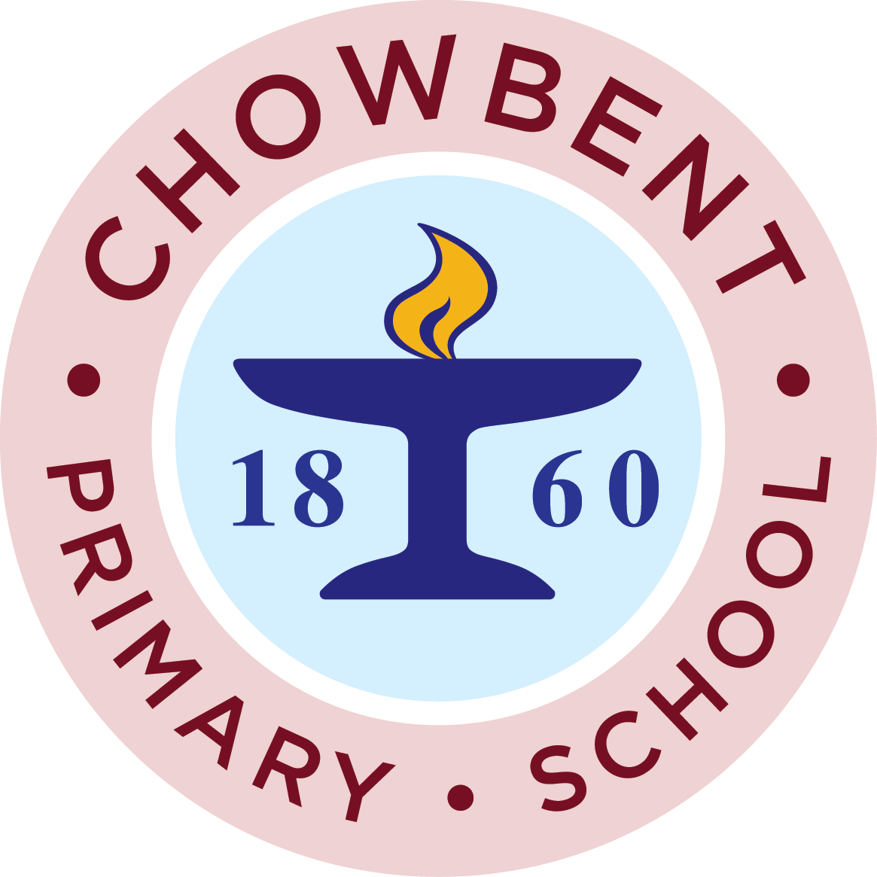
After a quiet half term we have a busy half term approaching and we are asking for your support.
We are having a non uniform day on Friday 1st March. We are asking for Easter egg or chocolate donations. These will be used in our Easter tombola which will be held after school on April 1st 2nd and 3rd. If you would prefer you can send £1 and we will use your donations to purchase items to be used at this event.
We are looking for parent helpers at this event so please if you can help between 3 and 3-45 on these days please let us know either via the office or the Facebook page.

Blue token scheme at Tesco
We are excited to announce that we have been accepted on to this scheme for the months of March and April. We are hoping to develop the playgrounds and provide some shady and quiet areas. We are guaranteed £1000 for being part of the scheme but the organization with the most tokens will get £4000 !!!
Please encourage all your friends and family to put their tokens into our container. We will be in the Atherton and Leigh branches of Tesco. Remember to ask for your tokens as the checkouts don't always remember.
Have a great half term
The PTFA

