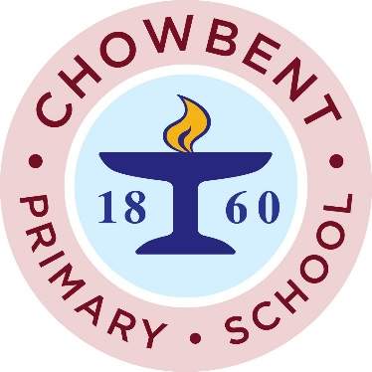

We will be holding our annual Book Fair after school on Monday 18th March – Thursday 21st March. We have a £1 book voucher for each child to be used at the book Fair, this will be given out to all children on World book day. Any additional money raised from the Book Fair sales will be used to support the development of the school's lending library.

