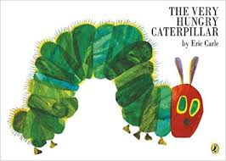
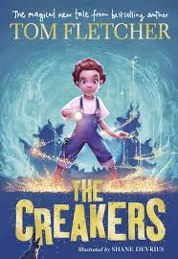


World Book Day
On Friday 8th March we will be celebrating World Book Day. Children are invited to attend school dressed as their favourite character out of a book. We are asking for children to bring in 2 books that they no longer want.1 book will be swapped and 1 book will be donated to the school library.
Thank you for your continued support.



