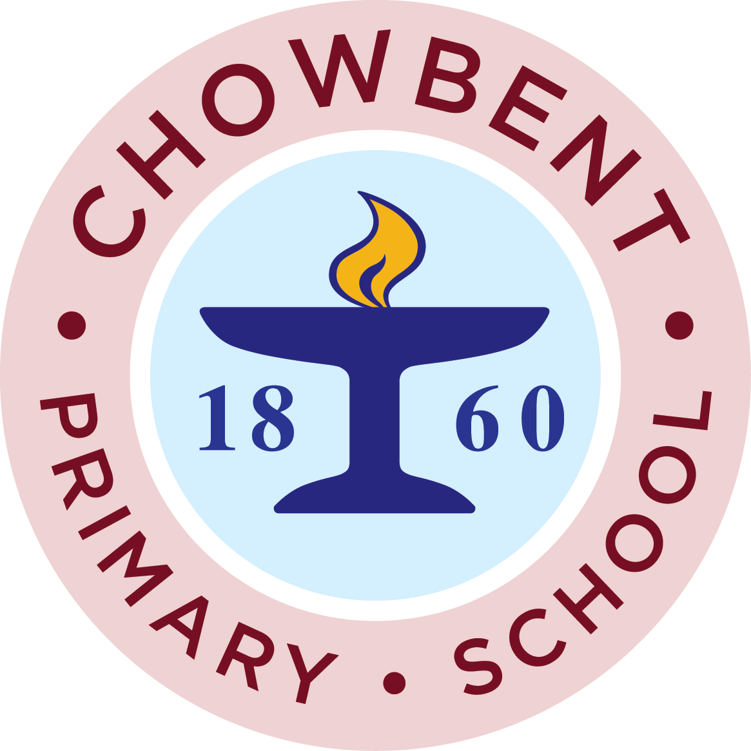

The PTFA exists to raise money for the benefit of every child in school.

Non Uniform day – Friday 24th May
We are asking you to send in any new items suitable for a tombola stall. This could include unwanted gifts, bottles of wine, new toys etc. If you would prefer you can send in £1

Mini Summer Fare – Friday June 28th
We are looking for anyone who can help to run a stall at our mini Summer fayre on June 28th after school. You would be needed from about 3pm until about 4 -30pm on that Friday afternoon. We are hoping to run a variety of stalls including tombola, hook a duck, lucky dice and refreshment stalls.
If you can help please tell the office or message the PTFA on facebook. We will then be in touch.

As we rush towards the end of the school year we would like to thank you for all your support this year. We will be in attendance at sports days where every child will receive a drink and also at Y6 performances where we will be selling raffle tickets and refreshments.
Our next meeting is on June 18th at 7-30pm in the Royal in Atherton. Everyone is welcome. If you have any suggestions for how you think the money raised should be spent why not come along and tell us or message us through Facebook. In past years we have bought tracksuits for the sports team, paid towards the stage, bought musical instruments and paid for Purple Mash.
The money raised does go back into school and help provide resources for everyone.

