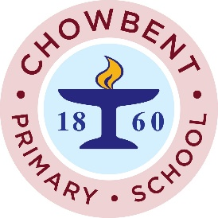

ATHERTON CARNIVAL
Just a reminder that it was the last Carnival Club tonight (10.06.2019) for our children in Y1 to Y6. We are looking forward to seeing everyone at Atherton Carnival on Sunday 23rd June.

Please note that on carnival day:
* Parents and children should meet us on Meadowbank Primary School car park at 11:30am.
* All children need to walk with a family member at all times during the carnival procession.
* Where possible, children should wear a green, yellow, blue or white T-shirt to represent the colours on the Brazilian flag.
*Carnival masks made by our children can be taken home after the carnival but Brazilian flags and musical instruments must be given back to a member of staff before you leave.
Thank you for your continued support,
Mrs Taylor


