

Citizen Science
Wigan Libraries Summer Reading
and Activity Challenge 2019
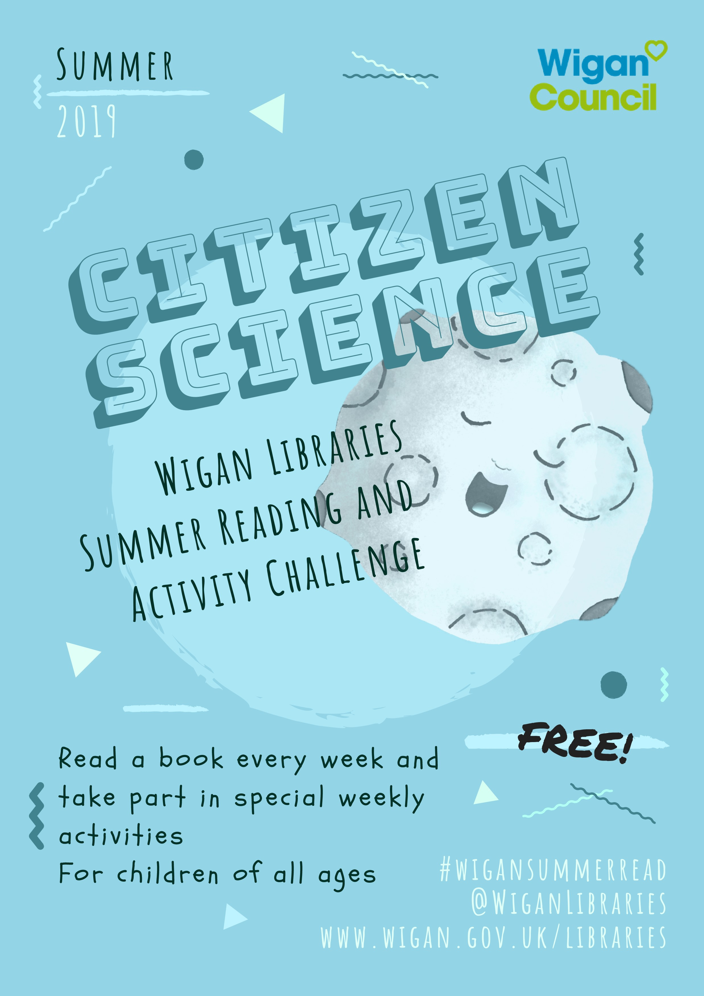

Wigan Libraries
Citizen Science Summer - What’s On!


Summer Events

What’s on at your local library this summer!

Tuesday 6th August  11:30-12:30am | Lamberhead Green Library | Build a Teddy
Tuesday 6th August  10-11am | Atherton Library | Monty The Dog
Wednesday 7th August  10am-12noon | Ince Library | Make Together
Wednesday 7th August  10-11am | Golborne Library | Build a Teddy
Thursday 8th August  2-3pm | Ashton Library | Build a Teddy
Friday 9th August  10am-12noon | Wigan Library | Make Together
Monday 12th August  10am-12noon | Atherton Library | Make Together
Monday 12th August  10:30am–1pm | Platt Bridge Library | Books, Games and Crafts drop-in
Wednesday 14th August  10-11am | Ashton Library | Monty The Dog
Wednesday 14th August  12-2pm | Shevington Library | Make Together
Friday 16th August  10am-12noon | Leigh Library | Make Together
Friday 16th August  2-4pm | Golborne Library | Make Together
Monday 19th August  10-11am | Leigh Library | Monty the Dog
Wednesday 21st August  10-12noon | Platt Bridge Library | Make Together
Friday 23rd August  10am-12noon | Aspull Library | Make Together
Tuesday 27th August  10-11am | Wigan Library | Monty the Dog
Wednesday 28th August  10am-12noon | Ashton Library | Make Together
Friday 30th August  2-4pm | Tyldesley Library | Make Together

Jet Packs
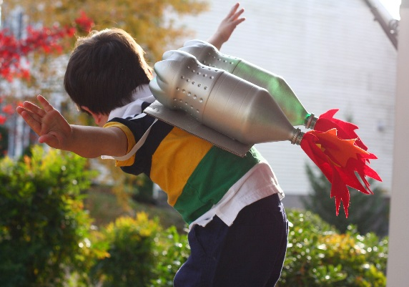
Looking for some upcycled crafty awesomeness this summer? Reserve a place at your local library today.
Come along and have great fun creating your jetpacks and then blast off and enjoy your jetpack all summer long.

£3 per child

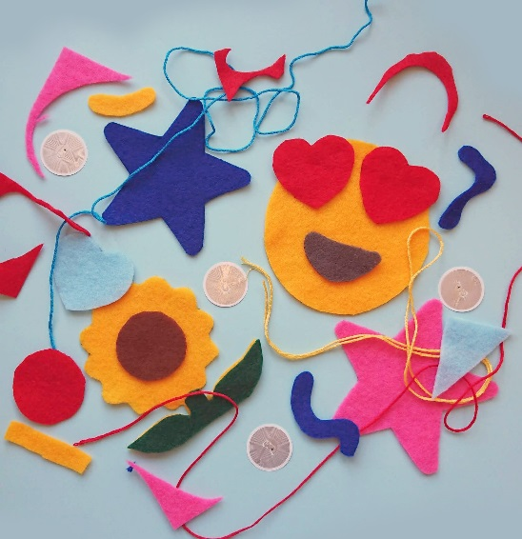
Make Together

The Digital Imagination Workshop has come to Wigan. Join us at your local library and craft keyrings and bookmarks with an exciting techy twist. Most suited to age 8+ but can be adapted to suit younger children.

£3 per child

Monty
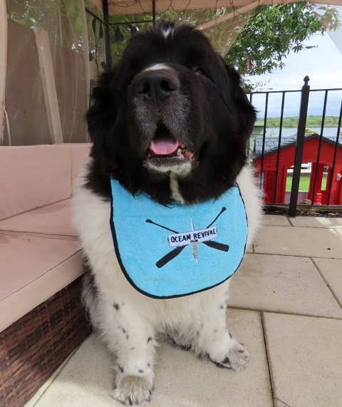
The Plastic Disaster Library Tour: come and meet the star of the hit new book for children Monty and the Ocean Rescue. Free story-time session for children with signed, pawtagraphed copies available to purchase on the day. www.montydogge.com

Free
How to Book

To reserve a place at any of our library events please contact the library directly:
Atherton Library: 01942 404817
Ashton Library: 01942 727119
Golborne Library: 01942 777800
Hindley Library and Community Centre: 01942 316455 or book on Facebook @Hindley Library and Community Centre
Lamberhead Green Library: 01942 705060
Leigh Library: 01942 404404
Platt Bridge Library: 01942 487997
Shevington Library: 01257 252618
Standish Library: 01257 400496
Tyldesley Library: 01942 404738
Wigan Library: 01942 827621
Alternatively; send @WiganLibraries a message on Facebook, or email library.transformation@wigan.gov.uk
#WiganSummerRead
Monday 22nd July  10-11am | Atherton Library | Jet Packing
Monday 22nd July  12:30-1:30pm | Tyldesley Library | Jet Packing
Monday 22nd July  10am-12pm | Hindley Library and Community Centre | Make Together
Monday 22nd July  11am-12pm | Hindley Library and Community Centre | Curious Critters
Monday 22nd July  10-11am | Standish Library | Pebble Trolls
Monday 22nd July  12:30-1:30pm | Shevington Library | Pebble Trolls
Tuesday 23rd July  10-11am | Hindley Library and Community Centre | Pebble Trolls
Tuesday 23rd July  1-2pm | Wigan Library | Pebble Trolls
Wednesday 24th July  10-11am | Leigh Library | Jet Packing
Wednesday 24th July  12:30-1:30pm | Hindley Library and Community Centre | Jet Packing
Wednesday 24th July  3-4pm | Ince Library | Jet Packing
Wednesday 24th July  10-11am | Lamberhead Green Library | Pebble Trolls
Wednesday 24th July  12:30-1:30pm | Golborne Library | Pebble Trolls
Wednesday 24th July  10-11am | Standish Library | Monty The Dog
Thursday 25th July  12:30-1:30pm | Ashton Library | Pebble Trolls
Thursday 25th July  3-4pm | Leigh Library | Pebble Trolls
Friday 26th July  12:30-1:30pm | Tyldesley Library | Pebble Trolls
Friday 26th July  3-4pm | Atherton Library | Pebble Trolls
Saturday 27th July  12pm-8pm | Hindley Library and  Community Centre | Family Gala Day

Monday 29th July  10-11am | Atherton Library | Build a Teddy
Monday 29th July  2-3pm | Tyldesley Library | Build a Teddy
Monday 29th July  10-11am | Hindley Library and Community Centre | Monty The Dog
Tuesday 30th July  10-11am | Shevington Library | Jet Packs
Tuesday 30th July  12:30-1:30pm | Standish Library | Jet Packs
Tuesday 30th July  3-4pm | Wigan Library | Jet Packs
Wednesday 31st July  10-11am | Lamberhead Green Library | Make Together
Wednesday 31st July  10-11am | Hindley Library and Community Centre | Build a Teddy
Wednesday 31st July  2-3pm | Leigh Library | Build a Teddy
Thursday 1st August  12:30-1:30pm | Ashton Library | Jet Packs
Thursday 1st August  3-4pm | Golborne Library | Jet Packs
Thursday 1st August  10-11am | Shevington Library | Build a Teddy
Thursday 1st August  2-3pm | Standish Library | Build a Teddy
Friday 2nd August  10-12noon | Wigan Library | Make Together
Friday 2nd August  2-4pm | Standish Library | Make Together
Monday 5th August  10-11am | Marsh Green Library | Build a Teddy
Monday 5th August  2-3pm | Wigan Library | Build a Teddy
Tuesday 6th August  11:30-12:30am | Lamberhead Green Library | Build a Teddy
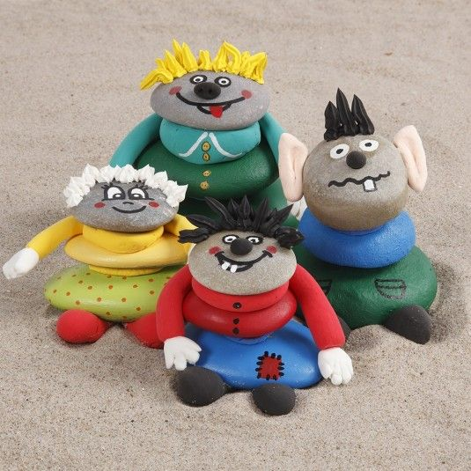
Pebble Trolls

More crafty fun, design and make your own Pebble Troll. What will yours look like? Suitable for all ages and abilities - all equipment and materials provided.

£5 per child

Build a Teddy
Make your very own 16” bear and design a t-shirt for your bear. Suitable for all ages and abilities – all equipment and materials provided, includes a large choice of bear skins, wish heart, t-shirt designed by you and a birth certificate.

£22 per child

