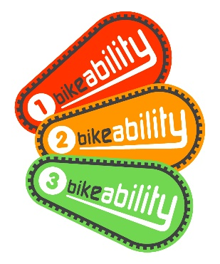


Opportunity for your child to participate in Bikeability cycle training
Dear Parent/Guardian
Chowbent has scheduled Bikeability Level 2 cycle training for our Year 6 children and I am writing to invite you to register your child to participate in Bikeability cycle training.
Bikeability Level 2 cycle training has been scheduled to take place during regular school hours during the week commencing 24/02/2020.
What is Bikeability Level 2?
Bikeability is the only UK government-recognised cycle training scheme, funded by the Department for Transport and is designed to teach pupils the skills and confidence to cycle safely.
The Bikeability Level 2 course is designed for children in years 5 & 6, comprising 2-hours Level 1 training in a traffic-free environment, followed by Level 2 sessions delivered over consecutive days. The course typically runs for a total of 8 hours and is designed to give your child the skills and confidence needed to ride on local roads, of the type that are often found around schools. In groups of up to twelve children, supervised by two qualified National Standard Instructors, your child will be taught how to safely deal with traffic on short journeys, such as the trip to school or the local park.
Cycle Experience Limited, your approved Bikeability Provider
Cycle Experience Limited is appointed by your Local Authority, having successfully demonstrated the ability as an Approved Bikeability Scheme Provider (appointed by the Department for Transport) to work with schools to deliver Bikeability cycle training.
Cycle Experience has delivered Bikeability cycle training to children for many years, supplying professional National Standard Instructors to deliver school cycle training programmes to more than 21,000 school children each year.
What will my child need to participate in Bikeability cycle training?
To participate in Bikeability cycle training, your child will need to bring a bike which is roadworthy and of the correct size, a cycle helmet and weather appropriate clothing and footwear for outdoors training. Please see the attached Bike, Helmet & Clothing Check Form to help ensure that you are able to meet all of these requirements and to guide you through checking the suitability of your child’s bike.
As your child will be attending a Bikeability Level 2 course, there will be the expectation that they are already able to ride their bike to Level 1 standard, are able to balance on their bike without support, look behind without wobbling and confidently hold a signal for at least 3 seconds. In order to cover several Health & Safety elements, as well as to assess each child’s current cycling ability, each child will receive a two-hour Bikeability Level 1 refresher on the school playground before progressing onto local, fully risk assessed minor roads.
How much will it cost to participate in Bikeability?
Bikeability is a government funded initiative which your Local Authority has received a grant to deliver Bikeability to as many children as possible. Unless otherwise stated in a separate letter from your Local Authority or school, Bikeability is completely free of charge and as a parent/guardian, you will not be required to pay for your child’s participation in Bikeability.
How do I book a place for my child?
There are a limited number of Bikeability places available, so please complete and return the attached Bikeability Consent Form to the school reception by Friday 31st January at the latest. Pupils will be accepted on a ‘first come, first served’ basis and you will be notified if your child has not been allocated a training place.
Yours sincerely,
J.Randle
Head Teacher.
Chowbent Primary School.

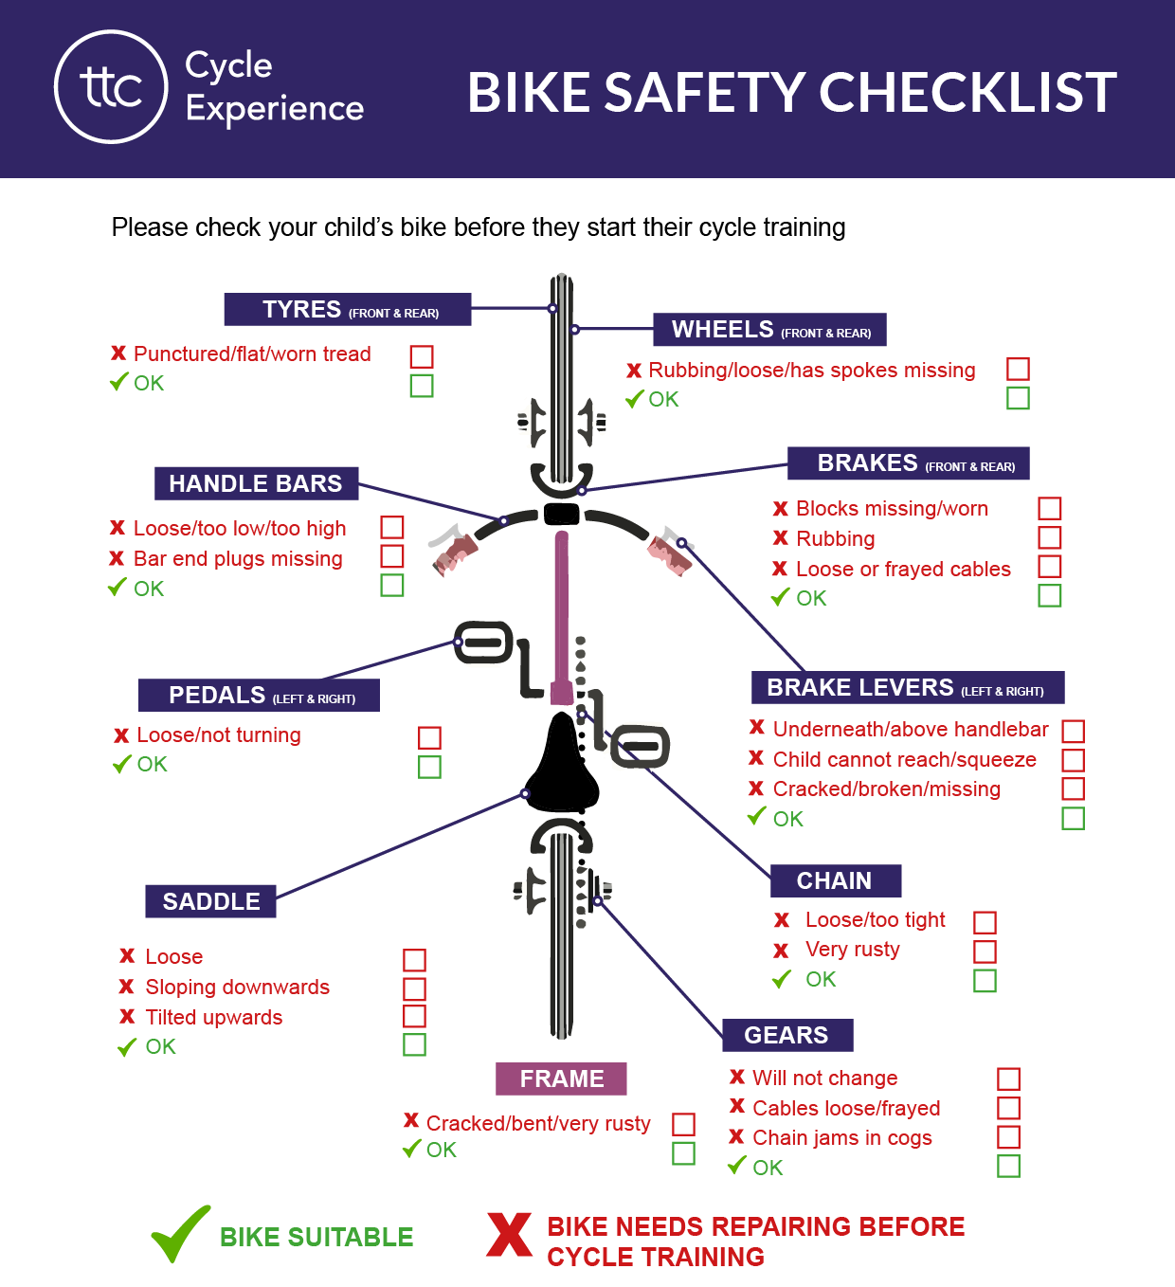
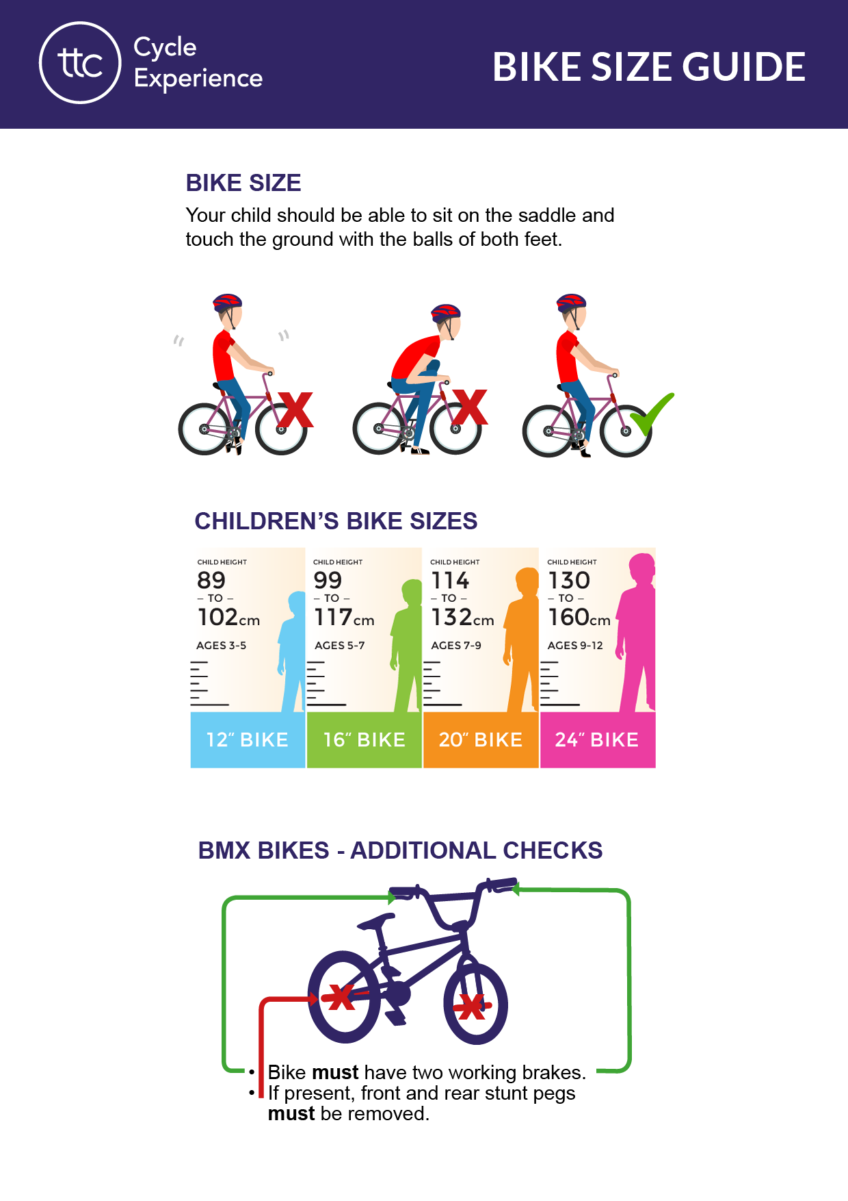
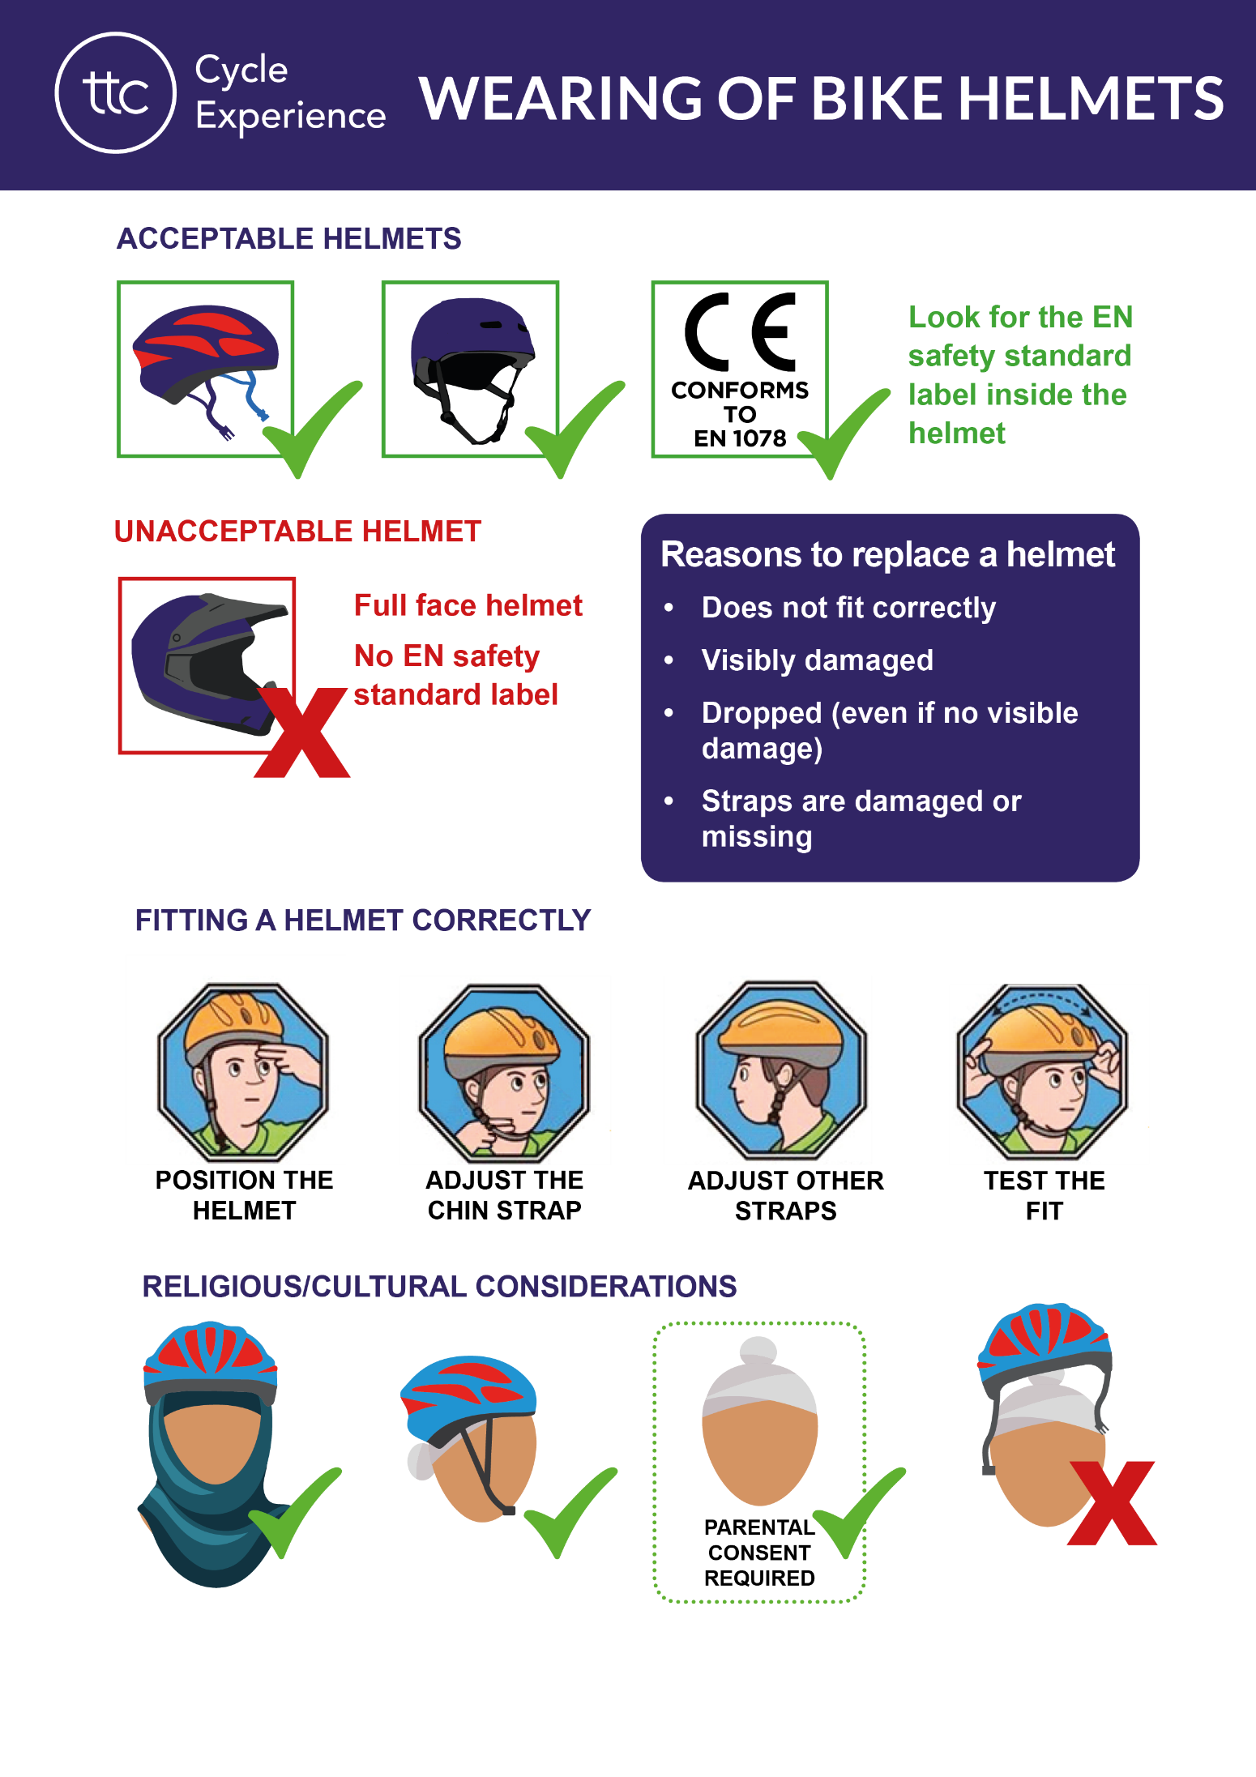
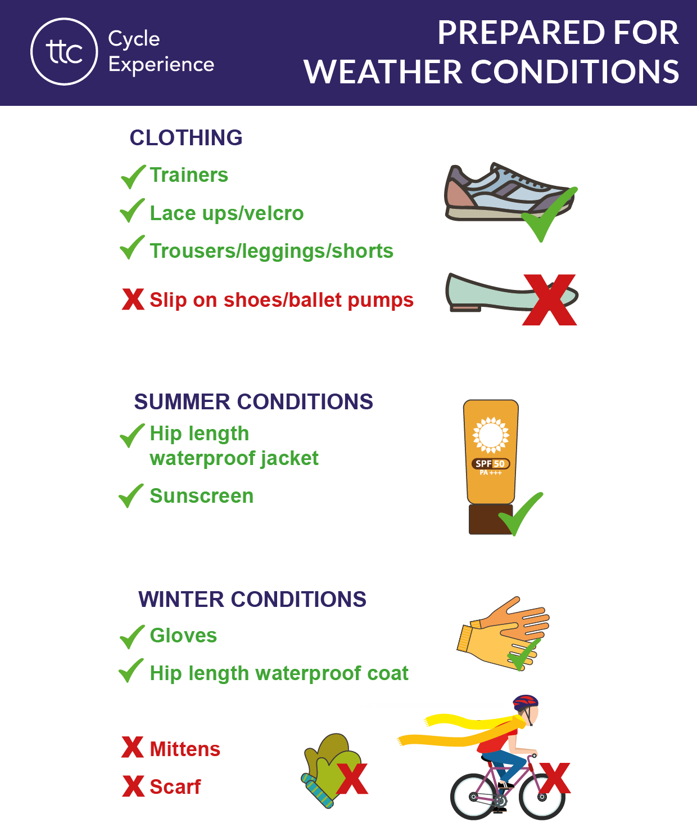

Bikeability Level 2 Consent Form
Full Name of Child (PLEASE PRINT)
Parent/Guardian Name (PLEASE PRINT)
Please tick the relevant consent boxes below:

I would like to register the above child to participate in Bikeability cycle training. I give consent to my child’s name, gender and any relevant SEND and/or medical information to be recorded within Cycle Experience Limited’s secure booking platform for the purpose of creating course registers, feedback reports and certificates.

I give consent for Cycle Experience Limited to know my child’s Surname for the generation of course achievement certificates.

I confirm that my child has a roadworthy bike and cycle helmet, both of which are the correct size and will be presented for use in Bikeability delivery.

I consent to photographs of Bikeability training delivery being taken by any of the following agencies, which may include photographs of my child, for marketing and promotion purposes:
- Local Authority
- School
- Cycle Experience Limited

PLEASE NOTE: A child can be exempt from wearing a protective cycle helmet for religious/cultural reasons ONLY.
I wish for my child to be exempt from wearing a helmet on religious/cultural grounds. I fully understand that Cycle Experience Limited cannot accept liability for any injury sustained as a result of my child not wearing a protective cycle helmet during Bikeability participation.

If you are declining the offer of Bikeability cycle training, would you please tell us why? Your feedback will help us to improve the services that we offer:

Medical or other conditions/requirements which may be of relevance on enabling your child to participate in Bikeability cycle training:

Parent/Guardian Signature:
Date:
Contact Telephone Number:
School Name:
PLEASE RETURN COMPLETED FORM TO YOUR CHILD’S SCHOOL

