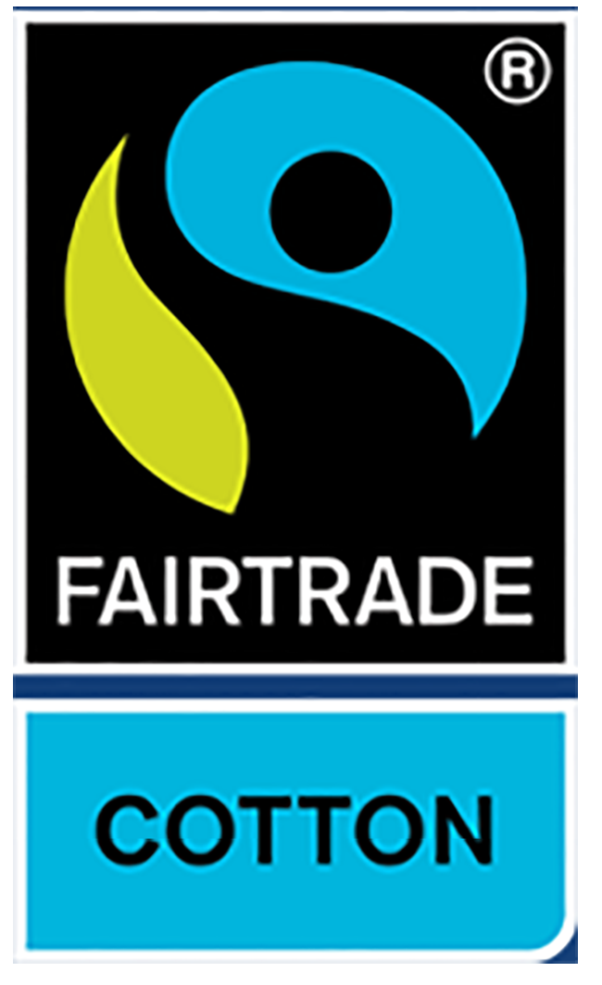
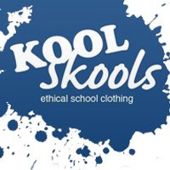
Koolskools Primary/Junior Schools Price List 2020
Fairtrade Cotton School Uniform Price list 2020.
All Koolskools Fairtrade Cotton School uniform is made with 50% Fairtrade cotton and 50% post-consumer recycled polyester. It is easy to wash and tumble dry, with little or no ironing necessary.
Koolskools FT Cotton Polo Shirt – with School Logo.

Premium Polo
Polo Size Chart ( Chest Inches) | 22 | 24 | 26 | 28 | 30 | 32 | 34 | 36
Age guide | 3-4 | 4-5 | 5-6 | 7-8 | 9-10 | 11-12 | XS | S
Price (Including School Logo) | £8.99 | £8.99 | £8.99 | £8.99 | £9.50 | £9.50 | £9.50 | £9.50

Koolskools FT Cotton Sweatshirt – With School Logo.

Deluxe Sweatshirt
Size Chart ( Chest Inches) | 22 | 24 | 26 | 28 | 30 | 32 | 34 | 36
Age guide | 3-4 | 4-5 | 5-6 | 7-8 | 9-10 | 11-12 | XS | S
Price (Including School Logo) | £10.99 | £10.99 | £10.99 | £10.99 | £12.99 | £12.99 | £12.99 | £12.99

Koolskools FT Cotton Cardigan – With Logo.

Cardigan
Size Chart ( Chest Inches) | 22 | 24 | 26 | 28 | 30 | 32 | 34 | 36
Age guide | 3-4 | 4-5 | 5-6 | 7-8 | 9-10 | 11-12 | XS | S
Price ( Including school logo) | £12.99 | £12.99 | £12.99 | £12.99 | £12.99 | £12.99 | £12.99 | £12.99

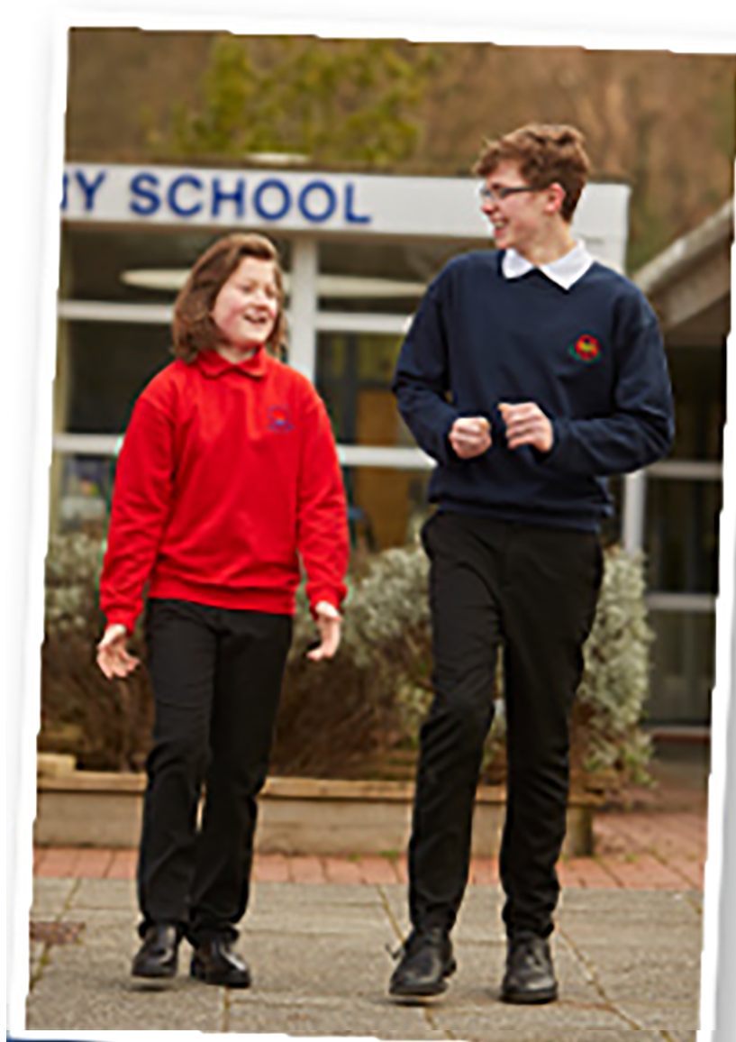
Larger garment sizes available on request.
Visit to place your order.

