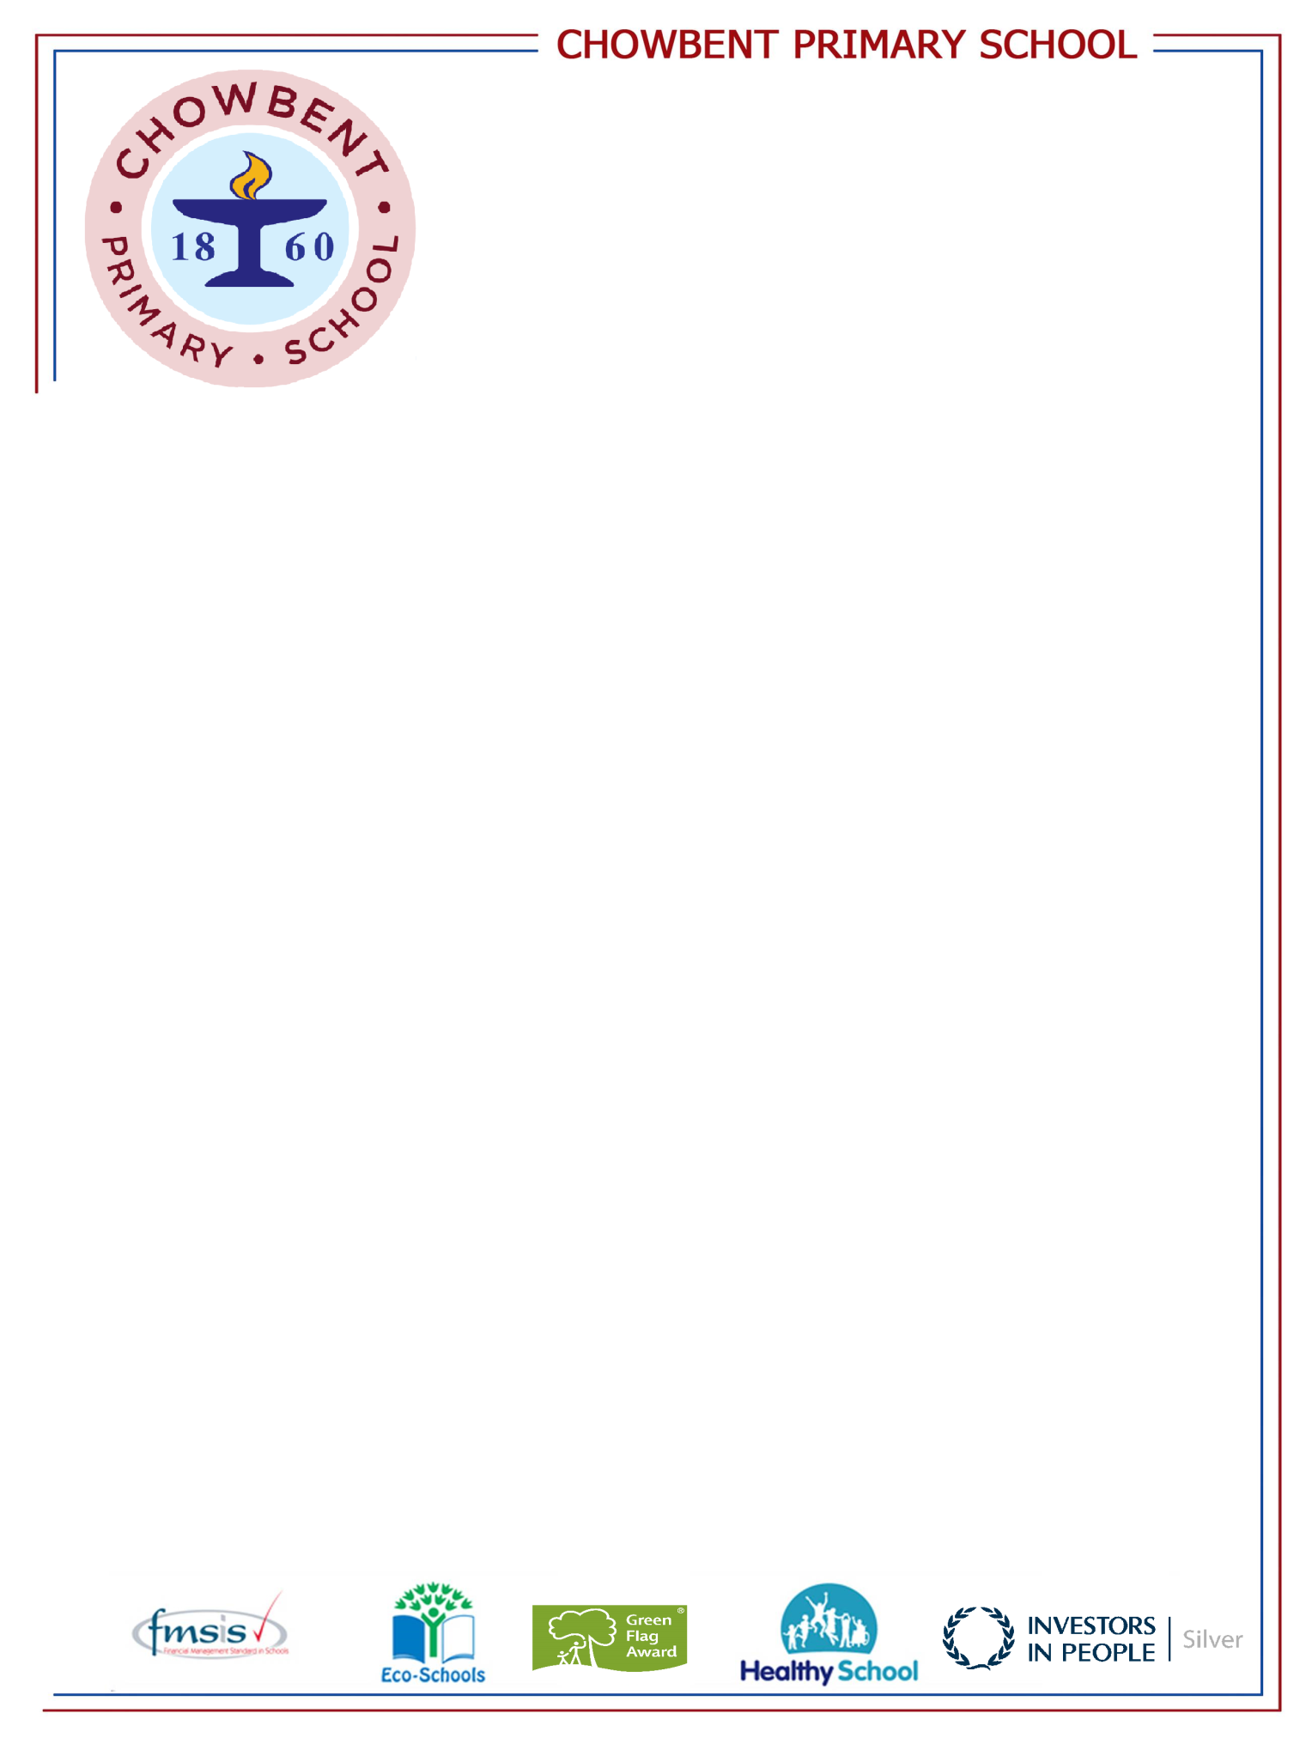
Laburnum Street
Atherton
Manchester
M46 9FP
Telephone: (01942) 883410
Fax: (01942) 897773
E-mail: enquiries@admin.chowbent.wigan.sch.uk
Web: www.chowbent.wigan.sch.uk

03/07/2020

Dear Parent / Guardian,

As your child moves to Year 3 in September 2020 they will no longer be entitled to universal free school meals. All school meals from the beginning of the autumn term will be chargeable at 2.25 per day. This can be paid via Lunch Shop and all meals must be paid for in advance and ordered at home. If you have forgotten your login details for Lunch shop you can reset your details via the website www.lunchshop.co.uk.

If your child is on benefit related free school meals you will not be charged for any meals ordered. Order dinners as you usually would via LunchShop.

If you think your child may be eligible to receive free school meals, through the benefits system, then please fill in the form attached and return to the school office / return to j.kendal@chowbentprimary.org.uk no later than Monday 13th July 2020.

Regards
Mrs Kendal

